

**UNIVERSITY OF PETROLEUM & ENERGY STUDIES**

**SCHOOL OF COMPUTER SCIENCE**

***Department of Cybernetics***

**GRAPHICS AND ANIMATIONS TOOLS**

LAB FILE

SESSION(2020-21)

Course: BTech with specialization in Open Source & Open Standards

Submitted to: Submitted by:

Dr. Durgansh Sharma Mridul Thapa

Associate Professor SAP: 500060077

Department of Cybernetics Roll no: R100217*039*

**VIVA-ASSIGNMENT**

**Ques 1)** create any Mountain Range with Snowfall over it using GIMP

ANS-

**Step 1.** Open Image in GIMP.

Use File>Open... command in the top menu or else just press Ctrl+O to open your image.

The “Open Image” dialog will appear, allowing you to navigate to the file and click on its name.

**Step 2.** Create a New Layer.

Press the D button to reset the background color to default (black).

Use Layer> New Layer or press Shift+Ctrl+N to create a new layer.

Change the snow layer's blend mode to Screen.

Press the D button to reset the foreground color to default (black).

**Step 3**. Apply the RGB Noise Filter to The Snow Effect Layer.

Select the Snow Effect layer on the Layers dialogue.

Use Filters>Noise>RGB Noise to apply the RGB Noise filter.

**Step 4.** Apply the Pixelize Filter to The Snow Effect Layer.

Make sure the Snow Effect layer is selected on the Layers dialogue.

To give the snow crystals effect, we apply the Pixelize filter by choosing Filters> Blur> Pixelize.

**Step 5.** Apply the Motion Blur filter.

Make sure the Snow Effect layer is selected on the Layers dialogue.

Now we'll apply the Motion Blur filter by going to Filters> Blur> Motion Blur...

The Motion Blur dialogue box appears. Here you can set Linear for Blur Type.

**Step 6.** Adjust the Levels.

The last step is to adjust the amount of snow by using Levels.

Use Color>Level, the Level's dialogue box appears.

Here you can set the Input Levels slider to get your desired snow effect.

**Step 7.** Save Document.

Use File>Save command in the top menu or else just press Ctrl+S to save your project file.

**OUTPUT-**

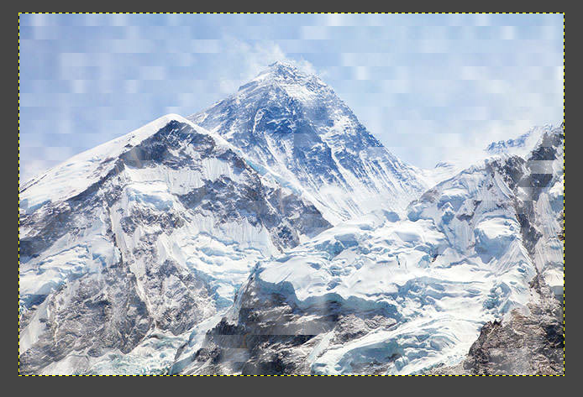

**Ques 2)** Design of Skyscraper using Blender

**ANS:**

**Step 1:** Open Blender, Create a blank file

**Step 3:** Add a plane and scale it to an average area of a building, using Shift+A>S.

**Step 4:** Switch to edit mode using TAB.

**Step 5:** Add some loop cuts using CTRL+R, to create a division of rooms inside the hut. Loop cuts are needed to be added with respect to X and Y axis.

**Step 6:** Now delete any one face on any level to bring the plane in L shape and extrude (E) it with respect to the z-axis such that to make a floor

**Step 7:** To make a dome on the roof, extrude from the corner from one of the end of the building block. Add a similar plane in between both floors to differentiate between them.

**Step 8:** Now add a camera and a light source to it. And arrange the camera to the best fit view.

**OUTPUT:**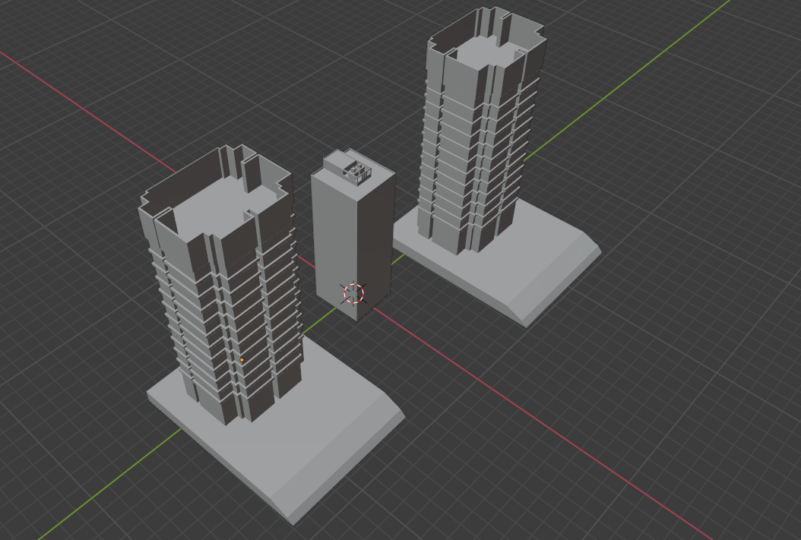

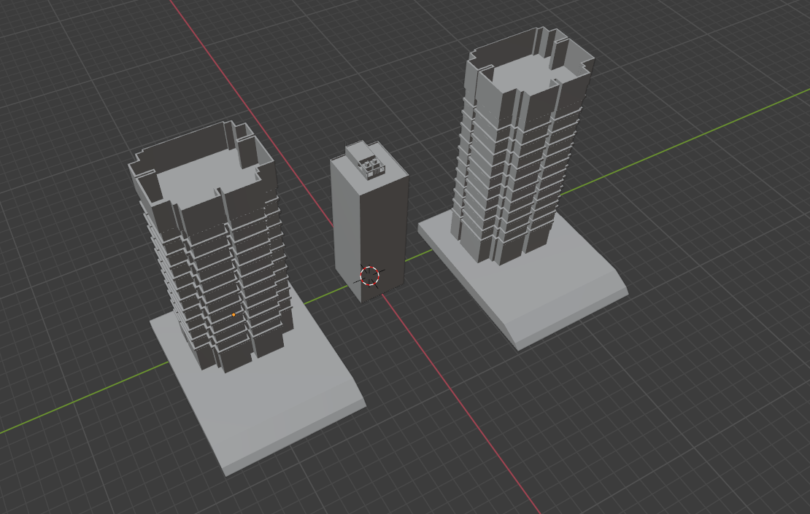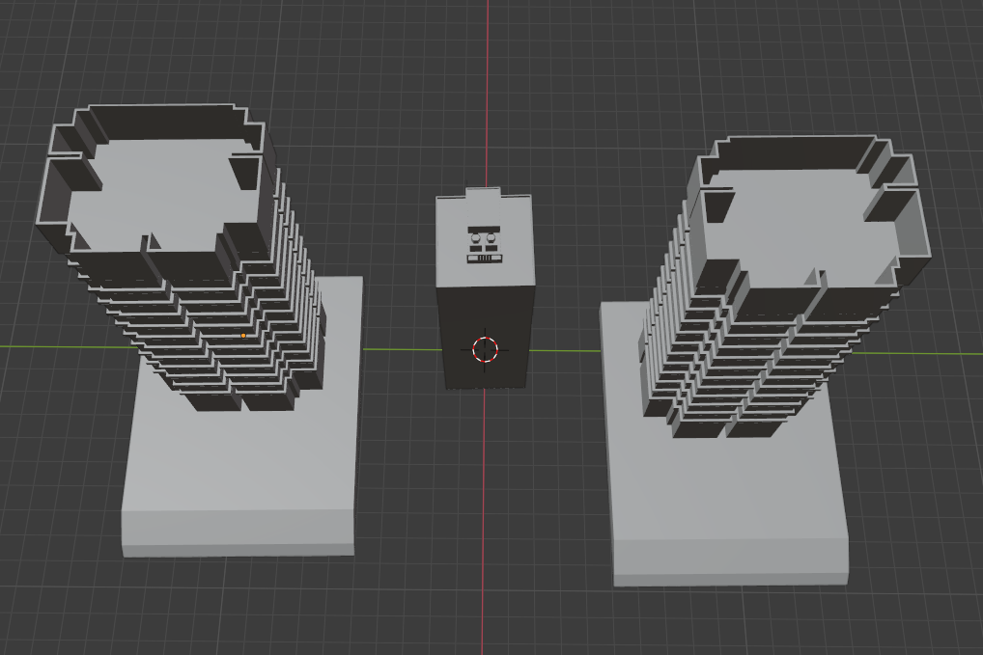

[**Link for the experiment file**](https://drive.google.com/drive/folders/1flTmZIImByf3y0i2nJoYBXPXMLePEHfe?usp=sharing)